

The Barn

Pershore

Worcestershire

WR10 1DP

**T:** 01386 291010

**www.jjaa.co.uk**

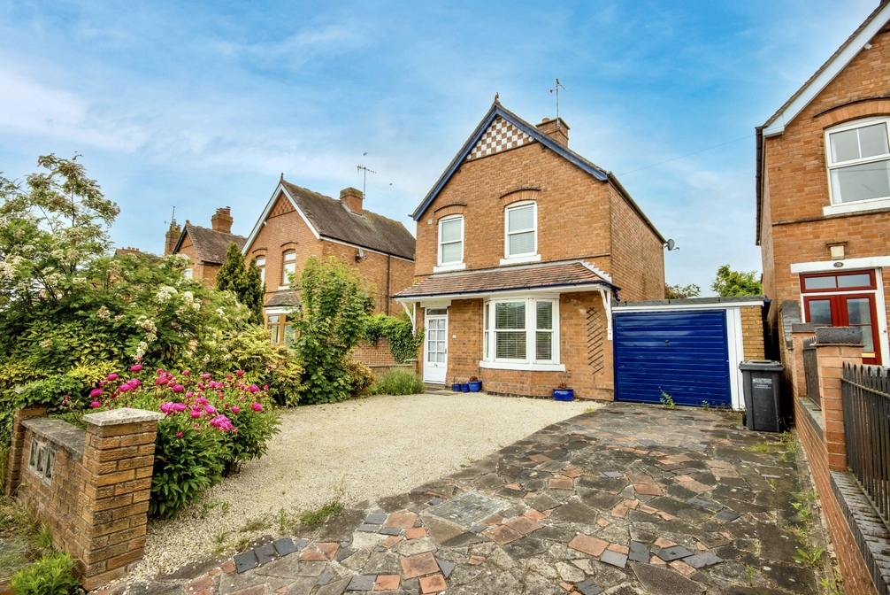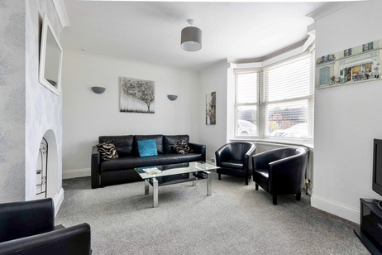

**Property Particulars**

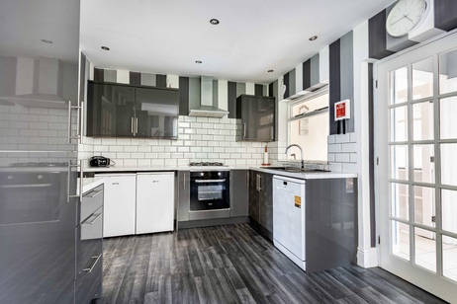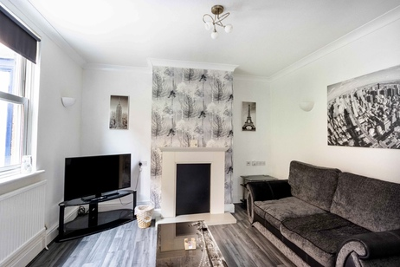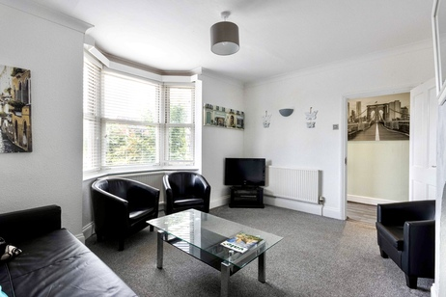

**29 Cheltenham Road, Evesham, Worcestershire WR11 1LA**

**£325,000**

* **Three bedroom detached Edwardian property**
* **A beautifully presented and extend.**
* **Living room, family room and a conservatory.**

A beautifully presented and extend three bedroom detached Edwardian property with a garage and within walking distance to the historic market town of Evesham, which offers a wide range of amenities.  
  
The accommodation comprises of an entrance porch, hallway with access to the cellar, living room with fireplace surround and a bay window, contemporary fitted kitchen / dining room having wall and base units with work surfaces over, gas hob with extractor fan, electric oven, space for three undercounter appliances and recessed lighting. From the dining area you can access the family room through French doors, the conservatory with lovely views of the rear garden, and a rear lobby giving access to the cloak room and the utility room, which has a door to the rear garden.  
  
The first has a landing area with access to the airing cupboard, three bedrooms with built-in wardrobes and a bathroom with independent shower.  
  
The property also benefits from a garage, double glazing throughout and gas fired central heating & hot water via a Vaillant boiler, which was installed in 2021.  
  
External  
  
To the front of the property is a spacious driveway with parking for several vehicles and access to the garage, which has a rear door to the garden.  
  
The well-presented rear garden has a patio seating area to the rear of the property, a lawn area with various established bedding plants and an additional secluded garden to the rear with lawn and a spacious seating area.  
  
Location  
  
The property is within walking distance to the historic market town of Evesham which offers a wide range of amenities to include shops, banks, building societies, Post Office, leisure Centre, restaurants, takeaways and Waitrose, Tesco & Morrisons supermarkets as well as an M&S food store. Whilst Evesham is well served for amenities, the larger centres of Worcester, Cheltenham and Stratford upon Avon are all within 15 miles. Transport communications are excellent with a mainline train station direct to London Paddington and the 18 tee Evesham golf club, situated in the vale of Evesham, is only 4 miles away and is considered one of the most picturesque golf courses in the UK.  
  
Tenure: FREEHOLD  
  
EPC Rating: E  
  
Local District Council: Wychavon  
  
Council Tax band: D  
  
Jones & Associates are the highest rated estate agent in Pershore & the surrounding villages for customer service, by Google customer reviews, and we have been involved in bespoke estate agency within the area for over 20 years whilst retaining an extensive network of independent estate agents throughout the London region and U.K., which means you receive a highly dedicated personal service backed up by extremely effective marketing and a vast proactive buyer network.

* **Contemporary fitted kitchen / dining room**
* **Downstairs cloakroom & utility room.**
* **Double glazing throughout and gas fired central heating & hot water via a Vaillant boiler. Installed in 2021.**

The Barn

Pershore

Worcestershire

WR10 1DP

**T:** 01386 291010

**www.jjaa.co.uk**

**Property Particulars**



